**Vrinda Store Data Analysis using MS Excel**

1. Compare the sales and orders using a single chart.

Solution :

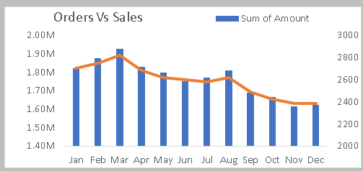

1. Which month got the highest sales and orders?

Solution : March



1. Who purchased more in 2022? Men or Women?

Solution : Women

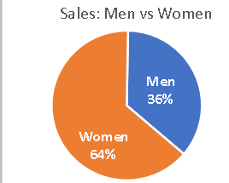

1. What are different order status in 2022?

Solution :

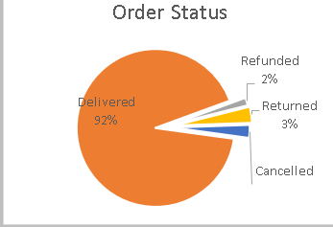

1. List Top 10 states contributing to the sales?

Solution :

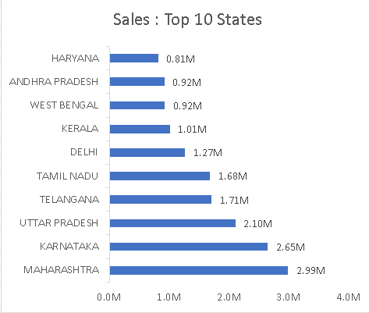

1. Show relation between age and gender based on number of orders.

Solution :

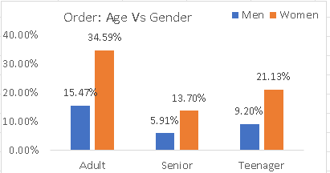

1. Which channel is contributing to maximum sales?

Solution : Amazon

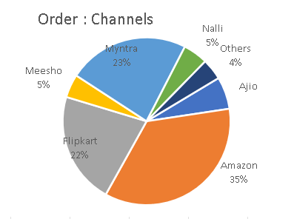

1. Which is the highest selling category?

Solution : Set 